1. This black and white print (Fig. 1) is missing the colors of the spectrum that is created when a beam of white light travels through a glass prism in air. Assume that the incident white light beam contains all wavelengths in the visible spectrum.

- On the right side of Fig. 1, draw arrows and indicate for each exiting beam what color the beam is.

- What if the incoming white light beam also contained infrared light? Draw an additional arrow and indicate roughly where the infrared light beam would end up after exiting the prism.
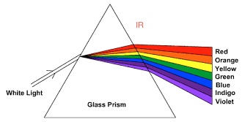

Fig. 1 Classic album cover, illustrating chromatic dispersion

2. Consider an objective that is labeled as having 100x magnification and Numerical Aperture
NA = 1.5. Let’s say that this is a Nikon objective, then the Tube Lens has f T.L. = 200 mm.
- What is the focal length of this objective?
ANSWER: 2 mm

- What is the maximum resolution you can expect to get when imaging with this objective, if all optics are perfect and aberration-free? Assume that you are imaging with green light of wavelength 510 nm.
ANSWER: 170 nm

- Say that you find a thread adaptor and put this objective in an Olympus microscope instead.
(In Olympus microscopes f T.L. = 180 mm). Will you get the same magnification as when you us the objective in the Nikon microscope that it is designed for?
ANSWER: NO

3. Two of the anatomical parts in the eye (Fig. 2) play the main part in refracting the light entering through the pupil to form an image on the retina. Which two?
Answer: LENS and the CORNEA .
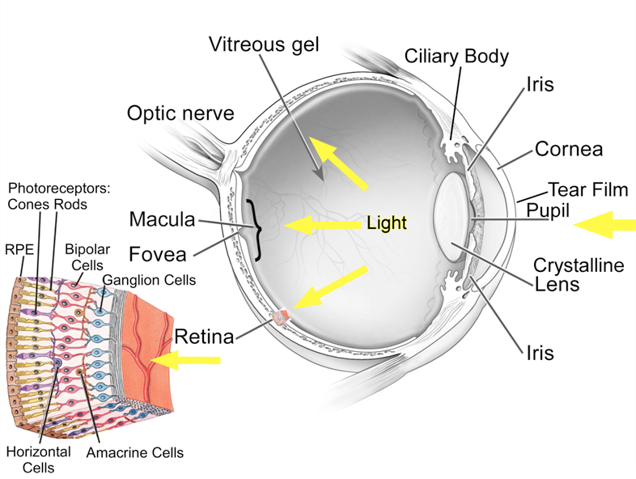
Fig. 2 Anatomy of the eye

4. Indicate with arrows: Where is the specimen plane (=objective front focal plane) and the image plane (=where you would put the camera sensor) located in the diagram of a microscope (Fig. 3) below, given the location of the Fourier plane (=pupil plane = back objective focal plane)?
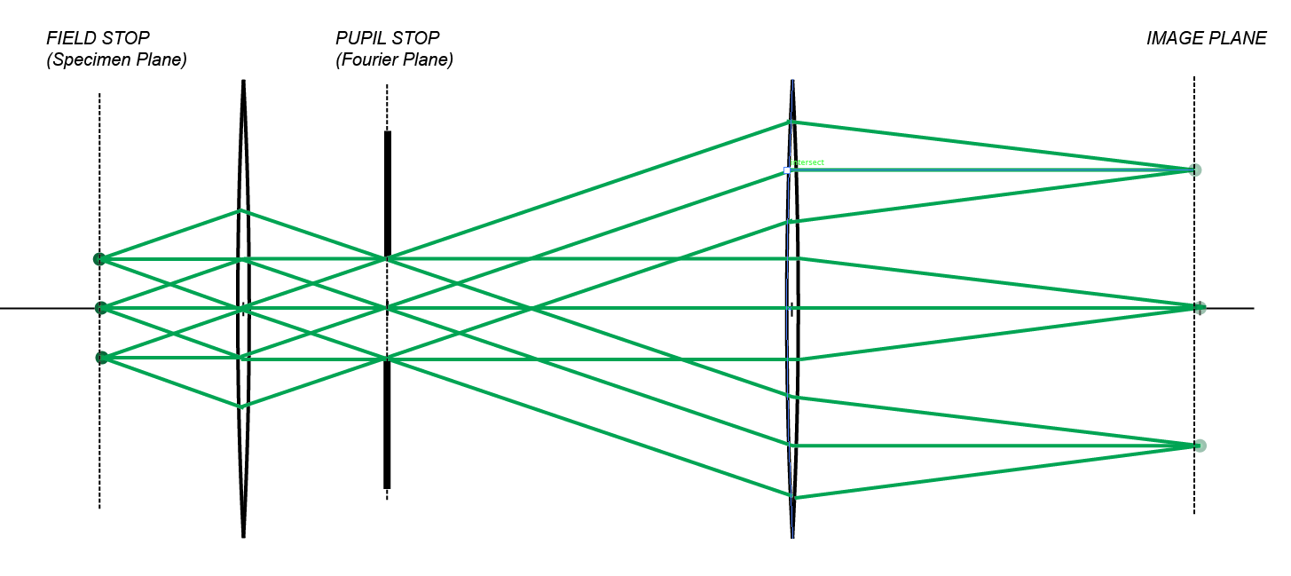
Fig. 3 Diagram of the principal rays through a microscope
5. What main type of aberration do we see in the lens and ray tracing diagram in Fig. 4?
Answer: SPHERICAL aberration

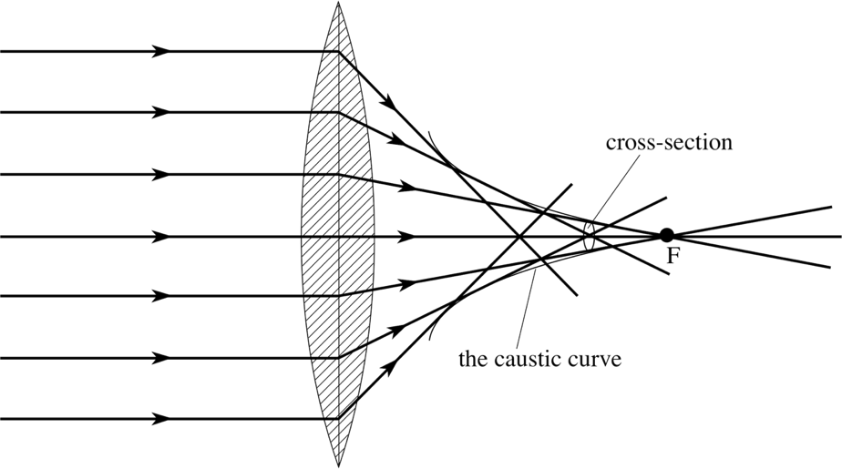
Fig. 4 A perfectly collimated “infinity beam” of light enters this thin lens and suffers a classical aberration.

